April 7, 2025

Testimony in Support of SB 1754
Before the Texas Senate Business and Commerce Committee
Brent Bennett, Ph.D.
Policy Director, Life:Powered
Texas Public Policy Foundation

Chairman King and members of the Committee,

Thank you for the opportunity to testify in support of SB 1754. Tax abatements for favored businesses and industries distort tax values and make broad tax relief for residents more difficult by shifting the tax burden onto a smaller base. This is why TPPF has consistently opposed programs like those enabled by Chapters 312, 380, 381. Tax breaks for wind and solar generators also facilitate the distortion of our electricity market, imposing a cost not just on residents of the taxing district but on the entire state. It is time to end this costly and useless enterprise.

Figure 1
Federal subsidies per unit of electricity generated, 2010 to 2023 (2023 USD/MWh)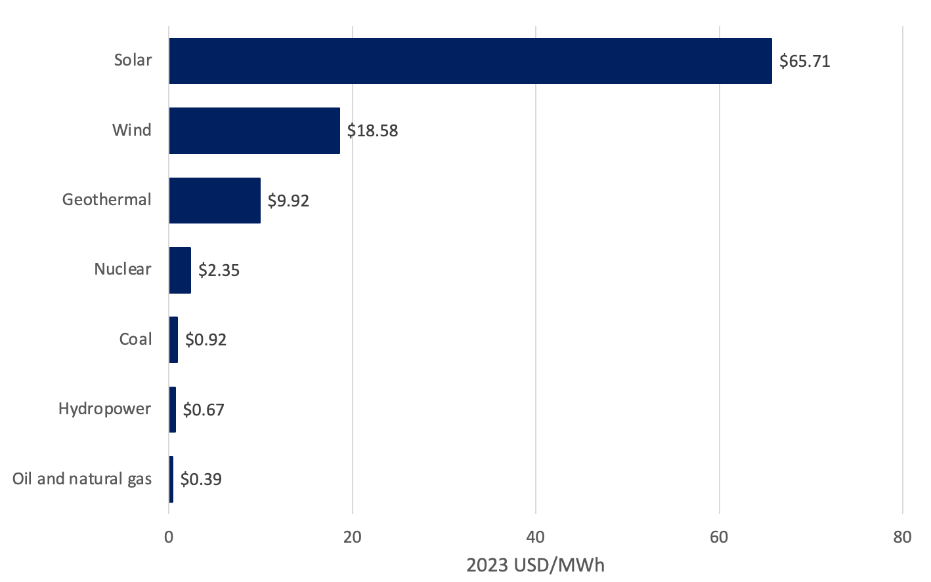
Source: B. Bennett, The Siren Song that Never Ends: Federal Energy Subsidies and Support from 2010 to 2023, Texas Public Policy Foundation, 2024, (https://www.texaspolicy.com/wp-content/uploads/2024/10/2024-10-LP-Federal-Energy-Subsidies-BrentBennett_FINAL-1.pdf).
The common refrain that “all energy resources are subsidized,” implying that energy subsidies among different resources are somewhat equal in size, might have held some water 20 years ago. However, since 2010, wind and solar have each taken in more federal energy subsidies⎯about $65 billion for wind and $75 billion for solar⎯than oil, natural gas, and coal combined. The picture is even more stark when looking at just the subsidies for electricity production, since wind and solar only produce electricity and nothing else. As shown in Figure 1, solar has pulled in $65 per MWh and wind nearly $20 per MWh of electricity produced since 2010. Natural gas generators are getting less than $0.40 per MWh in federal subsides, about 100 times less than wind and solar.

Recent estimates suggest that if the Inflation Reduction Act is not repealed, the cost of the production and investment tax credits for zero-emission resources, primarily wind and solar, could reach $1 trillion over the next decade, roughly 10 times what has been spent over the last decade. It would be reasonable to assume that using tax dollars to subsidize electricity production would reduce the cost of electricity, but the opposite is happening in Texas. Residential retail rates in Texas have risen 28% over the past 4 years and now exceed the residential rates in every neighboring state.

Subsidies for wind and solar are pushing the ERCOT market equilibrium far beyond where it would normally be, requiring dispatchable resources to be subsidized to maintain reliability. This situation is unsustainable and must be fixed now. The Texas Legislature removed wind and solar from receiving school property tax abatements, which are costing over $100 million annually, but existing Chapter 312 agreements are still costing between $40 and $50 million annually.

Over $130 billion in private capital, following almost $30 billion in subsidies, have poured into wind, solar and energy storage in Texas. Less than a quarter of this amount would have solved most of the problems that occurred during Winter Storm Uri and closed the reliability gap that we continue to face. This is the fundamental problem that Texas must address with its electric grid over the next decade. While much depends on the federal government eliminating its subsidy programs, eliminating all state and local subsidies, both direct and indirect, will help the situation. We appreciate Chairman Birdwell for addressing this ongoing problem and urge the legislature to pass SB 1754.

Sincerely,

Brent Bennett, Ph.D.
Policy Director, Life:Powered
Texas Public Policy Foundation

Fisher, T. & Loucks, J. (2025). The budgetary cost of the Inflation Reduction Act’s energy subsidies. Cato Institute. https://www.cato.org/policy-analysis/budgetary-cost-inflation-reduction-acts-energy-subsidies
U.S. Energy Information Administration. (n.d.). Electricity data browser: Average retail price of electricity, annual. Retrieved March 23, 2025, from https://www.eia.gov/electricity/data/browser/#/topic/7?agg=0,1&geo=vvvvvvvvvvvvo&freq=A
Peacock, B. (2021). Subsidies to nowhere. The Energy Alliance. https://static1.squarespace.com/static/5f08b9b336577f152f2c5c3e/t/6143c0845d7fd84c28ac5a6d/1631830153863/Subsidies-to-Nowhere.pdf

